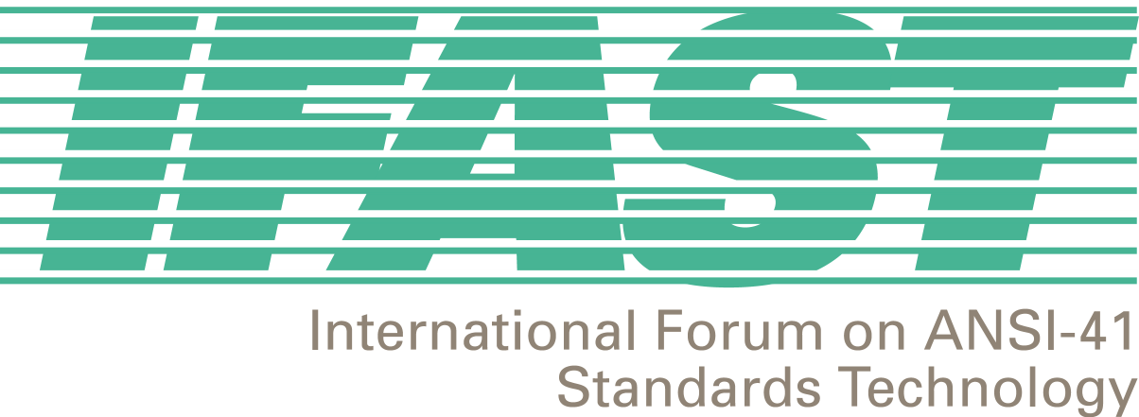

IFAST 19 Meeting
Calgary, Alberta, CANADA
6-7 June 2002

Agenda
Chaired by Fred Gaechter, Telcordia

1. Introductory Session

- Call to Order and Opening Remarks - Fred Gaechter (Telcordia)

- Attendance Roster and Introductions – Megan Hayes (ATIS) / Fred Gaechter (Telcordia)

- Agenda Review and Approval – Fred Gaechter(Telcordia)

- Introduction and Numbering of Contributions (Contributions will be numbered as follows: IFAST-02-06-06-XX) – Megan Hayes (ATIS)

- Next Meeting Decision – Fred Gaechter (Telcordia)
- September 25-26, 2002, Brazil (Sao Paulo, Rio de Janiero, Bahia)

2. Correspondence, Liaison and Update Session

- IFAST Website Update – Bernardo Martinez (IUSACELL)

- IRM/SID Update – David Crowe (Cellular Networking Perspectives)
- IRM Resource Management
- SID Reclamation Efforts

- IRM Assignment Database – David Crowe (Cellular Networking Perspectives) (IRM Administrator)

- TR45.2/3GPP2 Update – David Crowe (Cellular Networking Perspectives)

- GGRF Update - Enrique Hervas, (Telefonica Moviles)

- CITEL PCC1 Update – Victor Navarro (Ericsson)

- IFAST Financial Report – Megan Hayes (ATIS)

- Correspondence – Incoming and Outgoing – Megan Hayes (ATIS)
- SID Reclamation Letter
- CDG Permanent Liaison
- CAMEL and WIN Liaison letter to TR45.2 and TR46.3

- Cross Technology Roaming – Doug Rollender, (Lucent Technologies)

- Electronic News Letter

Plenary Session

- Review and resolve action items from IFAST18 – Fred Gaechter (Telcordia)

- Request of T1S1.3 for US SS7 Point Code assignment to entities in non-North American countries –Enrique Hervas (Telefonica Moviles, SAU) / Zaeem Hosain (Aeris Communications) / Fred Gaechter (Telcordia)

- Implementation Database – David Crowe (Cellular Networking Perspectives)

- Introduction of Other New Issues for Discussion at this Meeting – Fred Gaechter (Telcordia)

4. IFAST Study Project Updates

- IMSI Implementation, Backward Compatibility, and MIN-based IMSI versus True IMSI– Ied Al Shaer (Motorola) – this project is “dormant” subject to contribution, we will determine at this meeting its future status.
- Web Site Statement

- Uniform Dialing Plan, Support of Supplemental Services, and Future Feature Code Standardization – Fred Gaechter (Telcordia)
- Uniformity Survey Update

- IS-41 Based Services – Bernardo Martinez, (IUSACELL)
- WIN Survey Update
- List of technical implementation problems

- International Roaming Guide (IRG) – David Crowe (Cellular Networking Perspectives) and Syed Zaeem Hosain (Aeris Communications)
- Roaming Agreement Model
- Approve IRG Release 1.2

- Billing Related to International Roaming – (VACANT) – this project is “dormant” subject to contribution, we will determine at this meeting its future status.

- SS7 Routing Data – Fernando Fernandez (Compaq)

- ANI Compatibility – Ricardo Gomez and Bernardo Martinez (IUSACELL)

- IS-41 Implementation Awareness Project – Zaeem Hosain (Aeris Communications)

- Fraud – (VACANT)

Closing Plenary

- Agreements Review – Megan Hayes (ATIS)

- Action Items Review – Megan Hayes (ATIS)

- Closing Comments – Fred Gaechter (Telcordia)

