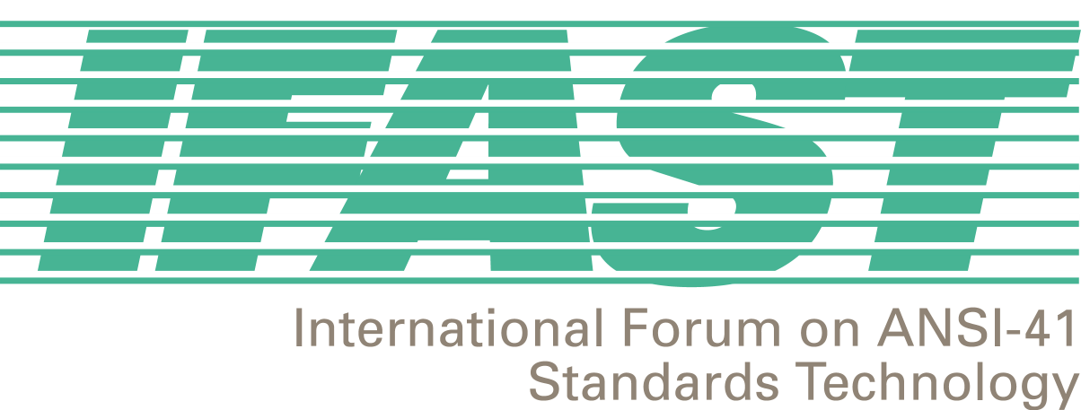

IFAST 18
San Francisco, CA, USA
22-24 January 2002

(Meeting starts at 9:00am)

Meeting Location: Marriott Fisherman’s Wharf
1250 Columbus Avenue

San Francisco, CA 94133
USA
http://www.marriott.com

Hotel Room Rate: $159 US

Hotel Reservation Cut-off: Please make reservations by December 22, 2001

Transportation: The Marriott Fisherman’s Wharf is located approximately 15 miles from the San Francisco International Airport. A shuttle from the airport will cost approximately $12US, and a taxi will cost $30US. For those wishing to rent cars, there is a parking fee of $30US per day.

For More Information, please contact Megan Hayes, IFAST Secretariat, at +1-202-662-8653, or via email at mhayes@atis.org.

IFAST –18 Meeting Registration:

Complete Registration Form and fax it to 202/393-5481 (secure fax) or contact Megan Hayes at 202/662-8653 or mhayes@atis.org.

