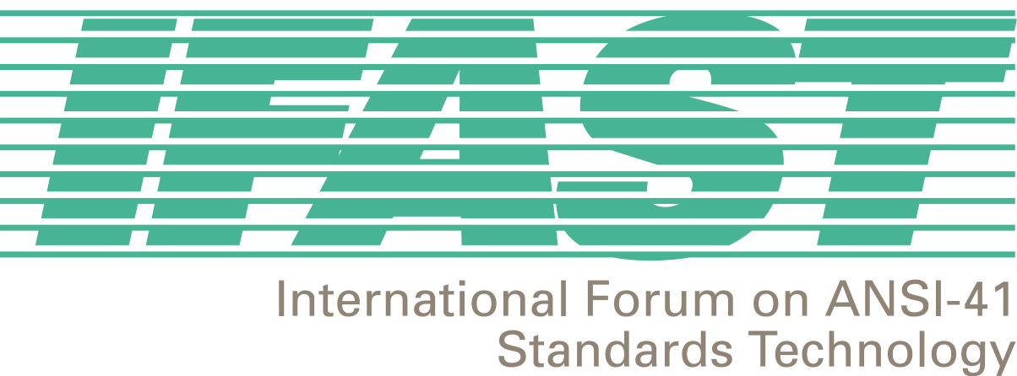
Sponsored by the Alliance for Telecommunications Industry Solutions (ATIS)

1200 G Street, NW, Suite 500
Washington, DC 20005
Tel: +1-202-662-8653
Fax: +1-202-393-5453
www.ifast.org

February 26, 2002

To: IFAST Membership

From: IFAST Chairman – Fred Gaechter (Telcordia)

Re: IFAST18 Overview and IFAST19 Meeting Announcement

I’d like to inform the IFAST membership of the significant results of our recent IFAST18 meeting and re-announcement the dates and location of the IFAST19 meeting, so that you can all mark your calendars.

IFAST19 is scheduled for June 6-7, 2002 in Calgary, Canada. The IFAST Secretariat (ATIS) will email the meeting announcement and registration form to all IFAST members within the next several weeks.

The IFAST18 meeting was held in San Francisco, California on January 23-24, 2002. Additionally, the day prior to the full IFAST meeting was devoted to discussions regarding the reorganization of IFAST. Many agreements were reached at both meetings that firmly positions IFAST in the middle of the current and future evolution and issues of the worldwide wireless industry.

The recent past of IFAST projects have been with regard to key current technical and operational issues within the international wireless industry, e.g., the assignment of ANSI SS7 Point Codes to service providers outside of North America. The IFAST membership recognized the need to expand our Mission and Scope in order to meet the rapidly evolving nature of the wireless industry. Let me highlight for you some of the more significant agreements, in this regard, made during the 1-day IFAST reorganization meeting:

- Expand our projects to include business issues. To date, the IFAST has dedicated its efforts to the resolution of technical and operational issues associated with the seamless implementation of international wireless services, e.g., international roaming. Every time that we discussed these issues we encountered associated business issues that had no identifiable forum for their resolution – IFAST is now that forum!

- Establish a new Fraud Project. One of the significant deterrents to the implementation and utilization of globally seamless international wireless services is the perception that there exists inherent fraud associated with these services. The IFAST will embark on a project that will address the real fraud issues and dispel the myth of other alleged issues.

- Established a new Management Team to better reflect IFAST’s international membership. The Management Team now includes the following:
  - IFAST Chairman – Fred Gaechter (Telcordia)
  - IFAST Secretariat – Megan Hayes (ATIS)
  - IRM/SID Administrator – David Crowe (Cellular Networking Perspectives)
  - Industry Members – Vice Chairpersons
    - United States – Zaeem Hosain (Aeris)
    - Canada – Watson Zen (Rogers Wireless)
    - Mexico – Bernardo Martinez (Iusacell)
    - Latin America – Adolfo Acevedo (Telefonica Moviles – Peru)
    - Asia – VACANT
    - Equipment Vendor – Doug Rollender (Lucent)

As you can see, there is no currently identified Asian Member on the Management Team. I would encourage any IFAST member willing to represent the Asian community on IFAST’s Management Team to contact me to discuss the roles of a Management Team member. This responsibility does not involve a significant amount of time – it mostly requires participation on Management Team conference calls that discuss managerial issues associated with the administration and organization of IFAST.

- Creation of new IFAST Mission and Scope statements. The members developed new statements that enable the IFAST to adapt to the ever-evolving environment of international wireless technologies and services. The new Mission and Scope are:

  - Mission: Increase the awareness and value of ANSI-41 networks to operators and their customers.
  - Scope: Facilitate the identification and resolution of issues to enable the interoperability of systems between countries, carriers, technologies, and standards, thereby protecting the investment made by the industry in the ANSI-41 family of standards while evolving to a seamless global network.

- Establish an IFAST Electronic Newsletter. This new Newsletter will regularly update IFAST members on topics, issues, and resolutions from IFAST meetings as well as report regional issues and successes with regard to the implementation of seamless wireless service.

Let me now highlight for you some of the more significant agreements made during the 2-day full IFAST meeting:

- Include “IRM Resource Management” issue on the IFAST19 meeting agenda. There is concern that current resource assignment projections (currently 57% fill rate) coupled with the potential for new services/capabilities requiring IRM assignment (e.g., smart cards, GSM-CDMA terminals) may soon exhaust this finite resource. We will discuss ways to mitigate or relieve such a potential exhaust. Whatever resolution is proposed at IFAST19 will impact all network operators, so your participation in this discussion is critical.

- Finalized a SID reclamation schedule. IFAST sent a letter to every country asking for assistance with the SID reclamation program – IFAST’s effort to reclaim unused, unassigned, and unneeded IRMs for reassignment and the resolution of assignment conflicts. The IFAST Secretariat will immediately send a reminder notice to all national administrations and then a letter by June 30, 2002 reinforcing that reclamation will occur on September 30, 2002 if there is no response to the IFAST letters.

- Approved an IFAST Awareness Project schedule. This is a 2-year extensive project intended to increase and expand the awareness of and participation in IFAST. The schedule is accessible on the IFAST web site.

- Revised and updated the International Roaming Guide (IRG). This is the IFAST’s primary document that contains information pertinent to wireless service providers to assist them in the implementation of seamless services. This newly approved iteration is Release 1.2 and can be downloaded from the IFAST web site.

- Established the dates and location for IFAST20 – September 25-26, 2002 in Brazil.

IFAST has been a very productive and effective forum to date. With the new Mission, Scope, and Organization, IFAST will be even more effective in the future. We do, however, require active participation in order to ensure that IFAST can continue to assist the international wireless community in the future – PLEASE HELP IFAST TO HELP YOU!

