November 2001 | WIRELESS UNIFORMITY SURVEY | 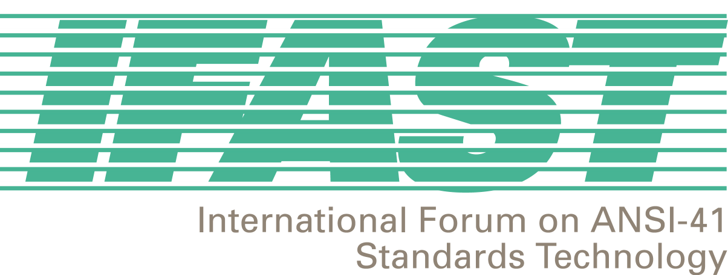
GENERAL INFORMATION |  | CONTACT INFORMATION
Question 1: Which of the following Technologies does your network support?  (Place an “X” after “Yes” for those Technologies deployed in your network.) Is your deployment with or without authentication? (Place an “X” after “W” if with authentication or after “WO” if without authentication.) | Question 2: Does/will your network offer International Roaming Service?  (Please provide the date that you will offer the service, if not currently available. If you are currently or are intending to offer the Service, please tell us what past or ongoing difficulties/concerns you had/have in offering the Service. If you are not intending to offer the Service in the foreseeable future, please tell us what specifically caused you to make that decision, complete the Contact Information and proceed to Question 8.) | Company Name:  Contact Name:  Contact Address:  Contact Telephone Number:  Contact Facsimile Number:  Contact Email Address:  (“Contact”: person answering the questions that can be contacted for further or clarifying information.)
Answer:  Analog Yes W WO  TDMA Yes W WO  CDMA Yes W WO  GSM Yes W WO | Answer:

BASIC SERVICES
Question 3: What basic services, (e.g.,  customer service, directory assistance,  emergency calling, long distance operator  access, etc.) do you offer to international roamers on your network? | Question 4: How do/will international  roamers access basic services on your network?
Answer: | Answer:

SUPPLEMENTARY SERVICES
Question 5: What supplementary services  (e.g., call forwarding, call waiting, conference  calling, etc.) do you offer to international roamers on your network? | Question 6: How do/will international roamers  access Supplementary Services on your network? | Question 7: How are international roamers  aware that they have successfully accessed,  activated, and deactivated Supplementary  Services on your network (e.g., tones, announcements)?
Answer: | Answer: | Answer:
NETWORK ANNOUNCEMENTS |  | GENERAL COMMENTS:
Question 8: If/when announcements are  used in your network, what language(s) are  used? |  | Question 9: Do you have comments or additional useful information regarding this survey and/or the IFAST potential study of service uniformity? Also, please tell us of any other issues/concerns, related to international roaming, that you feel the IFAST should study and resolve, particularly those that would assist service providers in the offering of International Roaming Service.
Answer: |  | Comments:

Please return completed surveys to Megan Hayes no later than December 21, 2001. Completed surveys may be faxed to +1 202 393 5453, or sent via email to mhayes@atis.org.

