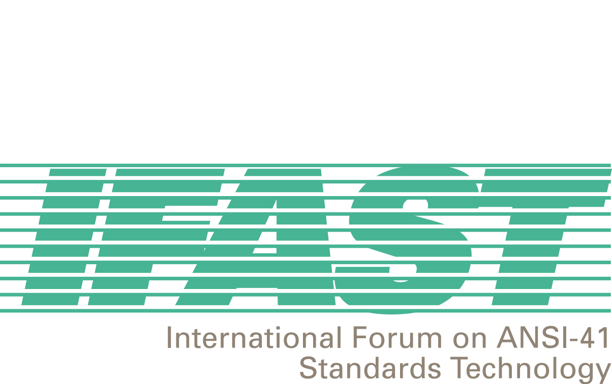


October 24, 2001

To: ANSI-41-based Wireless Service Providers Offering International Roaming Service

Fred: International Forum on ANSI-41 Standards Technology (IFAST)

Re: Dialing, Services, and Features Uniformity

One of the main objectives of the International Forum on ANSI-41 Standards Technology (IFAST) is to identify and resolve any impediments to the successful and ubiquitous offering of international roaming services on ANSI-41-based networks. The IFAST believes that internationally mobile wireless subscribers are keenly interested in a viable international roaming service. Such a service, in order to be successful, requires “ease of use”, including the uniformity of dialing and services/features access. Such uniformity offers subscriber familiarity, which encourages subscription and use.

Consequently, the IFAST has undertaken to study the potential for international uniformity in network and services aspects in order to make international roaming more attractive to wireless subscribers. Some of the components of the study include:

- Uniformity in offering services to international roamers.
- Uniformity of the dialing method to access services, e.g., customer service, directory service, emergency calling, access to long-distance operator service, Supplementary Services.
- Uniformity of subscriber activation/deactivation awareness by tones/announcements.
- Uniformity of Feature Code access to Supplementary Services.

The IFAST is aware that many of these components are embedded differently in existing network functionality globally and, therefore, may be difficult to make uniform. However, the IFAST has determined to proceed with those components where there is the potential for, at least, partial uniformity. The first step in this project is to determine what the current implementations are globally with regard to these components. Hence, the IFAST has developed a survey for distribution to ANSI-41-based network operators. The goal of the survey is to catalog current dialing and service implementations as a starting point for determining how to best proceed with the uniformity project.

The survey is attached. It is requested that your organization review the survey, respond to the questions to the best of your ability, and return the completed survey to the IFAST. The contents of your response will be treated confidentially – there will be no reports that identify the answers of specific respondents and only the IFAST staff and management team will view the actual responses. If you have any questions regarding the completion and submittal of the survey, please contact Megan Hayes (ATIS), IFAST Secretariat. Megan can be contacted at +1 202 662 8653 or, by email, at mhayes@atis.org. If you have any questions regarding the content and use of the survey, please contact Fred Gaechter (Telcordia), IFAST Chairman. Fred can be contact at +1 973 423 3443 (business hours – New York time) or, by email, at fredgaechter@monmouth.com.

The completed survey should be faxed to Megan at +1 202 393 5453, by December 21, 2001. If you prefer to respond electronically (email to Megan), the survey is available for downloading on the IFAST web site. Once the surveys are received by the IFAST, the results will be aggregated and analyzed to determine how to proceed with the study, if at all. Once this determination is made, the IFAST will provide the results of the survey and the method by which the IFAST will proceed with its study.

The IFAST requests your support for this project by answering the survey. The answers will help to make international roaming successful and profitable for subscribers and service providers.

Fred Gaechter
Chairman, IFAST

