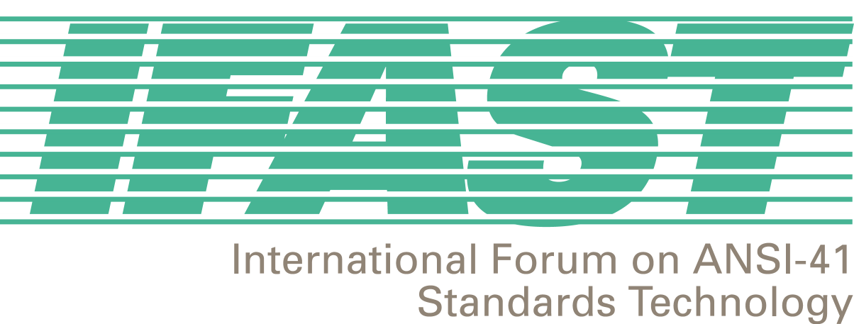

IFAST 17
Tampa, Florida, USA
12-13 September 2001

(Meeting starts at 12:00 p.m.)

Hotel: Hyatt Regency Westshore
6200 Courtney Campbell Causeway
Tampa, FL 33607
USA
Tel: +1-813-874-1234
Fax: +1-813-281-9168
http://www.hyatt.com/usa/tampa/hotels/hotel_tparw.html

Rate: US$159.00/Night

Reservation Please make your own hotel reservation before

Cut-off Date: 20 August 2001

Transportation: The Hyatt Regency Westshore is located 2 miles from the Tampa International Airport.

IFAST –17 Meeting Registration:

Complete Registration Form and fax it to 202/393-5481 (secure fax) or contact Megan Hayes at 202/662-8653 or mhayes@atis.org.

