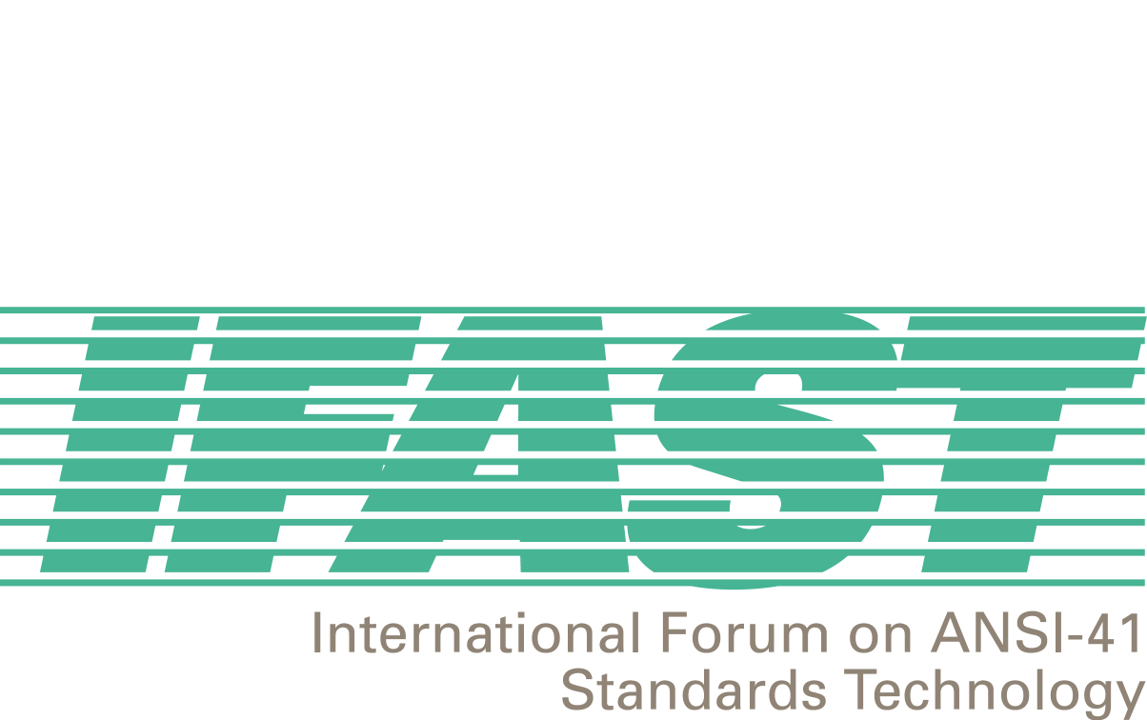

November 8, 2001

To: IFAST Membership
From: Fred Gaechter, Chairman
Re: IFAST Schedule

Greetings,

As you are aware, IFAST17 was held in Washington, DC, 23-24 October 2001. We thank CTIA for their generosity in allowing us to use their meeting space. The meeting resolved several significant issues presented by IFAST members, reached numerous additional agreements, created numerous new action items and scheduled the IFAST18 and IFAST19 meetings. Those that attended this meeting participated in a lively and constructive discussion of all the agenda items, (thanks to all participants!). The attached files contain the Agreements Reached, and Action Items. The contents of these files attest to the current productivity of and future potential for IFAST.

Per the agreements reached and action items from the IFAST17 meeting, IFAST will launch an awareness project to make carriers aware of the importance of implementing the current IS-41 standards, particularly in the context of international roaming. There will be a conference call held 26 November 2001 to develop an outline for the design and implementation of this project. Information on the conference bridge for this call is included at the bottom of this message.

The IFAST18 meeting is scheduled for 22-24 January 2002 in San Francisco, CA. The meeting announcement and registration form is available on the IFAST web site at http://www.ifast.org. This meeting was extended to two and one half days in order to allocate a full day to discuss the mission, scope and charter for IFAST. This particular session is scheduled for the first day with the normal IFAST agenda scheduled for the following day and a half. There was some interest expressed at the IFAST17 meeting to expand the mission and scope of IFAST in order to deal with larger array of issues with regards to all aspects of international roaming not currently contained in the mission, scope and charter. There will be a planning session conference call to discuss the agenda for this organizational meeting on 18 December 2001 beginning at 11am ET. Information on the conference bridge is included at the bottom of this message.

Finally, it was agreed that the IFAST19 meeting will take place in Calgary, Alberta, 28-29 May 2002. Special thanks goes to David Crowe, Cellular Networking Perspectives, for offering to host this meeting.

Best Regards,

Fred

IFAST Schedule (November 2001-May 2002)

Date | Type | Issue | Details
26 November 2001  11:00am Eastern Time | Conference Call | IS-41 Implementation Awareness Project | Dial In Number:  +1-703-326-5155  PassCode: 566 0358
18 December 2001  10:00am-1:00pm Eastern Time | Conference Call | Planning session for IFAST18 Organizational Meeting | Dial In Number:  +1-703-326-5155  PassCode: 566 0362
22-24 January 2002 | Face-to-face meeting | IFAST18 | San Francisco, California  Marriott Fisherman’s Wharf
28-29 May 2002 | Face-to-face meeting | IFAST19 | Calgary, Alberta, Canada specific location TBD.

