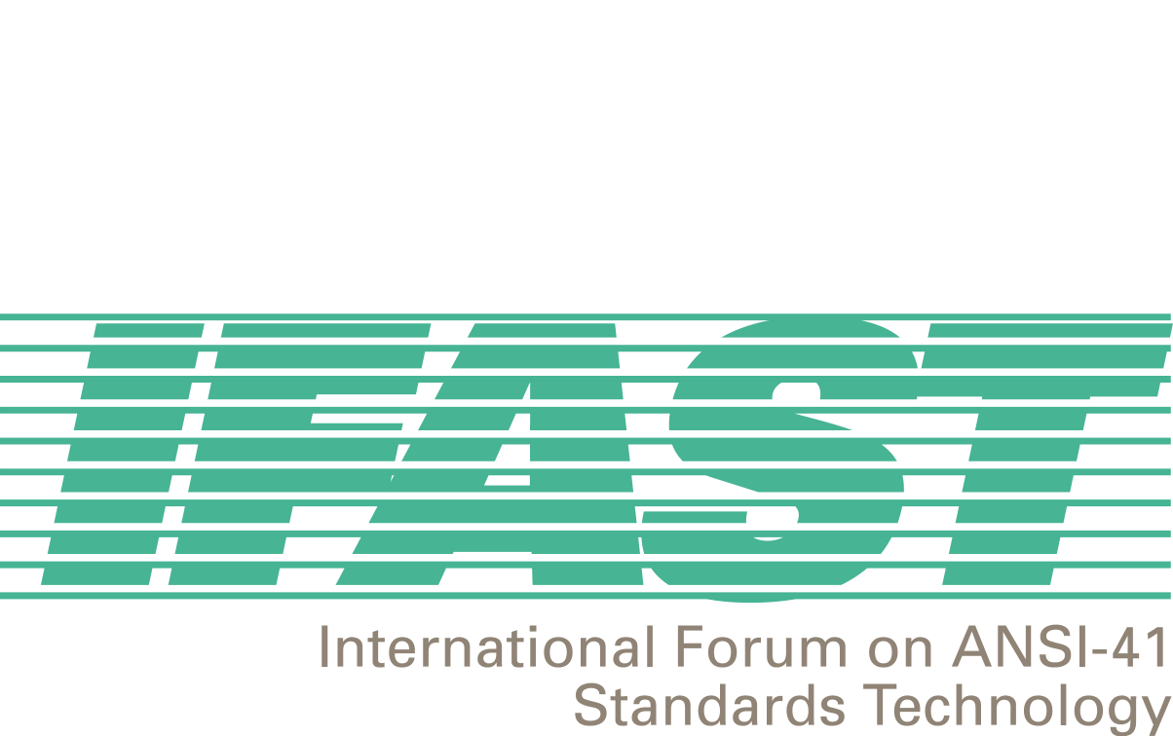
IFAST 16 Meeting
Ixtapa, Mexico
15-16 May 2001

Agenda
Chaired by Fred Gaechter

1. Introductory Session

- Call to Order and Opening Remarks - Fred Gaechter(Telcordia)

- Attendance Roster and Introductions – Megan Hayes (ATIS) / Fred Gaechter (Telcordia)

- Agenda Review and Approval – Fred Gaechter(Telcordia)

- Introduction and Numbering of Contributions – Megan Hayes (ATIS)

2. Correspondence, Liaison and Update Session

- IFAST Website Update and Billing Schedule – Bernardo Martinez (IUSACELL)

- IRM/SID Update – David Crowe (Cellular Networking Perspectives)

- IRM Assignment Database – David Crowe (Cellular Networking Perspectives) (IRM Administrator)

- TR45.2 Update – David Crowe (Cellular Networking Perspectives)

- IRM Fee Updates – Megan Hayes (ATIS)

- UPS Resource Conflicts

- Correspondence – Incoming and Outgoing (including letters from IFAST14 Action Items) – Megan Hayes (ATIS)

Plenary Session

- Review and resolve action items from IFAST15 – Fred Gaechter (Telcordia)

- Modifications to IRM Assignment Guidelines – Fred Gaechter (Telcordia)

- Modifications to the SID Assignment Guidelines – David Crowe (Cellular Networking Perspectives)

- Contribution to T1S1.3 regarding assignment of US SS7 Point Codes –Enrique Hervas(Telefonica Moviles, SAU) / Zaeem Hosain (Aeris Communications) / Fred Gaechter (Telcordia)

- Report on T1S1 Meeting
- Develop answers to T1S1 questions
- Discuss next steps

- WIN Services – Watson Zan (Rogers Wireless)

- Development of J-STD-038 – Doug Rollender (Lucent Technologies)

- Introduction of Other New Issues for Discussion at this Meeting – Fred Gaechter (Telcordia)

4. IFAST Study Project Updates

- International TLDN – Bernardo Martinez and Ricardo Gomez (IUSACELL)

- IMSI Implementation, Backward Compatibility, and MIN-based IMSI versus True IMSI– Ied Al Shaer (Motorola)

- Uniform Dialing Plan, Support of Supplemental Services, and Future Feature Code Standardization – Fred Gaechter (Telcordia)

- WIN-based Services – VACANT

- International Roaming Guide (IRG) – David Crowe (Cellular Networking Perspectives) and Syed Zaeem Hosain (Aeris Communications)

- Billing Related to International Roaming – VACANT

- SS7 Routing Data – VACANT

- Roaming Agreement Modeling – Aldofo Acevedo (Telefonica Moviles de Peru)

- ANI Compatibility – Ricardo Gomez and Bernardo Martinez (IUSACELL)

Closing Plenary

- Next Meeting Decision – Fred Gaechter (Telcordia)

- Agreements Review – Megan Hayes (ATIS)

- Action Items Review – Megan Hayes (ATIS)

- Closing Comments – Fred Gaechter (Telcordia)

