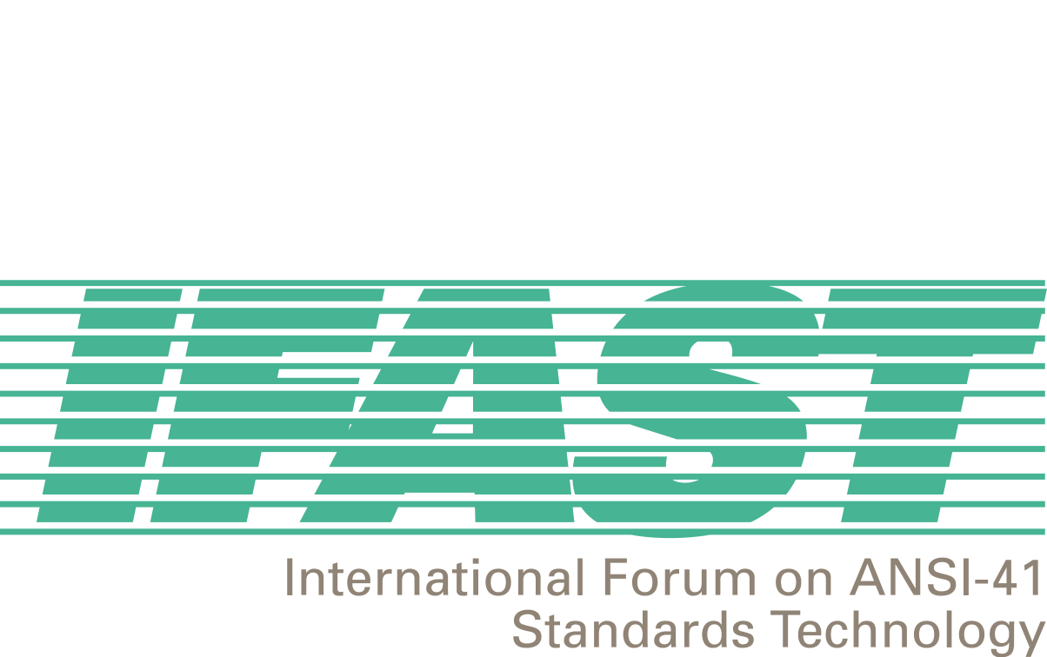

April 4, 2001

IFAST Members,

As you might recall, yesterday was the day that IFAST presented its contribution to ANSI Committee T1S1 requesting the allocation of ANSI SS7 Point Codes to non-North American wireless entities. Following is a brief synopsis of the results of that presentation:

- The IFAST presenters were myself, Syed Zaeem Hosain of Aeris, and Enrique Hervas of Telefonica Moviles. We had limited time for our presentation, but despite that, were able to adequately introduce our issue. I presented the content of the contribution, Enrique presented slides that he developed explaining the difficulty of changing point codes when changing service networks, and Zaeem presented the difficulties encountered by a US-based service provider implementing an expanded network outside North America.
- There were numerous questions asked, but no outright objections to proceeding with our issue. The questions related more to implementing our request than approving it - a fact that shows both an understanding of the topic as well as a proclivity towards granting out request. In fact the T1S1.3 Chairman informed me at the end of the meeting that he heard no immediate objections to our request. That alone bodes well for our issue, at least for now. It is not, however, a successful conclusion, yet. There will be plenty of time for those entities that might eventually oppose our request to put their case together.
- There was no final agreement, at this time, to allocate SS7 DPCs to non-North American entities. There was, however, unanimous agreement to continue discussion of the issue in the following manner:
- We will receive a list of questions from T1S1 early next week, via the T1S1 Chairman (Bob Hall of SBC). We developed most of these questions prior to having to leave to catch our respective flights. They are reasonable questions in the context of our request, but they will take considerable effort to answer.
- We will forward our answers to the questions by the close of our next meeting - early-June.
- We will attend the next T1S1 meeting in late-June to further introduce our answers and to participate in continuing discussion. The stated "goal" - not a commitment - of T1S1.3 will be to resolve the issue at that meeting.
- However, most of the management of T1S1 feels that it is more likely to reach an agreement on our request at their October 2001 meeting.

I know this seems like an inordinate amount of time for the resolution of such an issue, especially considering the fact that there was no expressed opposition to our proposal. However, there was also no expressed direct support for the proposal and such a period of time for the resolution of an issue in the T1 process is not unusual. In fact, there is the potential that whatever the solution is, particularly if it supports our request, might require a letter ballot to obtain a consensus result - a process contained defined time intervals.

All in all, I feel good about the outcome of the meeting. Going in, this outcome was pretty much what I anticipated. If anything, the result is better than anticipated in that there were no outright expressions of opposition to our proposal and request.

If we are to succeed, however, there will be significant work ahead to answer the T1S1 questions satisfactorily. I will forward them to you as soon as I receive them and will immediately form a working group to start compiling and drafting our answers. Honestly, we will need more help and support than was received with regard to presenting and supporting the contribution, or we will not succeed.

In this context, those of you that can and are willing to, please respond to me by the end of next week (April 13, 2001) offering your name to be on the working group. If there are not adequate volunteers, we will have to consider dropping the project and withdrawing our request from T1S1.

I thank Zaeem and Enrique for giving their valuable time and effort to this presentation (Enrique traveled all the way from Spain to assist in the presentation), David Crowe for assisting in the final text and providing me a last minute technical briefing, and Megan Hayes for assisting with the logistics of posting the contribution to the T1S1 web site (sounds like an Academy Awards acceptance speech!). I'm sorry if I've missed anyone that contributed as significantly as those mentioned above.

I look forward to a successful conclusion to this effort. I firmly believe that we are right in our request and that we can succeed.

Best Regards,

Fred Gaechter

