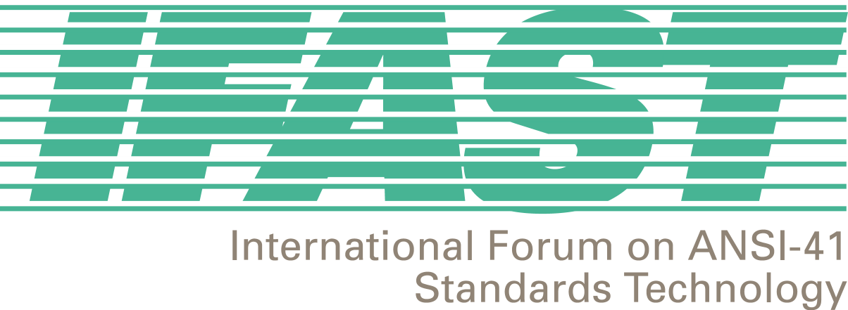

March 8, 2001

IFAST Associates,

As you are aware, for more than a year we have been discussing the need to assign ANSI SS7 Point Codes to non-North American wireless entities offering international roaming service. At IFAST 14 (October, 2000), in Lima Peru, it was unanimously agreed to develop a contribution to ANSI Committee T1S1 requesting a revision in the Point Code Assignment Guidelines to authorize such international assignments. At IFAST15 (January 2001), in Carmel California, the support for the contribution to T1S1 was reiterated. IFAST members were requested to consider participating in the presentation of the contribution at the April 2-6, 2001 meeting of T1S1 (Phoenix) and to request their T1S1 representatives to support the contribution at that meeting.

I’m not going to take the time in this letter to reiterate all the technical and business reasons that these Point Codes are necessary – they were made abundantly clear during our recent discussions. Suffice it to say, international roaming services can not succeed and, therefore, revenues can not be realized, without these resource allocations. There is also compelling evidence that the minimal resources required will not jeopardize the availability of Point Code resources for North American entities.

Unless there is active support from North American entities at the T1S1 meeting, it will be difficult to convince the T1S1 members of the technical and business requirements for the assignment of ANSI Point Codes internationally.

This letter is to follow-up with all of you to seek your support in this regard. I urgently need to hear from those of you that can attend the April T1S1 meeting to assist in the presentation of the contribution as well as those of you that have obtained support from your T1S1 participants. Without this support, I don’t feel good about our chances of success. This type of issue is the reason for IFAST’s existence. We need to show our resolve and support for our agreements to the worldwide wireless community.

Please contact me directly either at 973 423 3443 or by email at fredgaechter@monmouth.com.

Thanks for your help and support,

Fred Gaechter
IFAST Chairman

