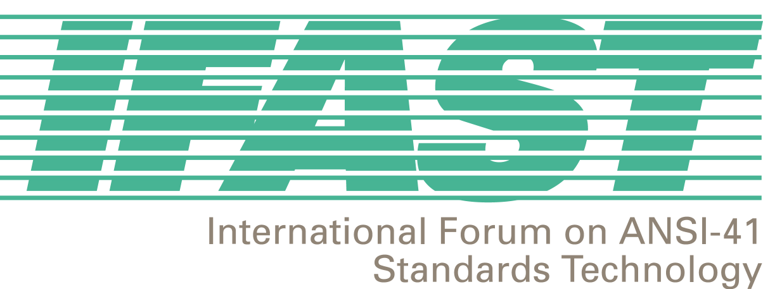

January 19, 2001

I am writing to inform you of the agreement reached at the IFAST14 meeting in Lima, Peru regarding International TLDN. Those present agreed to ensure the activation of the proper ANSI-41D parameter in mobile systems to accept an international TLDN field of up to 15 digits.

A Temporary Local Directory Number (TLDN) is used to route calls to a roamer on a visited ANSI-41 system. As the name implies, this directory number is local (up to 10 digits in the North American Dialing Plan) in nature. TLDNs as implemented today do not include a country code (CC) thereby making a TLDN unable to dial international numbers.

As ANSI-41 continues to grow and cross international boundaries, the need for an expanded TLDN (15 digits to accommodate country codes (CC)) is becoming apparent. IS-41 Rev. C calls for the implementation of a TLDN up to 15 digits. However, many carriers worldwide have not yet implemented this feature. Since ANSI-41 was originally developed to support the North American Dialing Plan, only 10 digit TLDNs were allowed in the protocol’s early implementation. National and International TLDNs are distinguished by the Nature of Number (NON) field and consequently, can co-exist. However, systems that support the International TLDN cannot successfully transmit this format to a system that does not.

IFAST discussions have revealed that many carriers have been utilizing creative ways to temporarily deal with the problem such as converting an international TLDN to 10 digits by using a three-digit code that translates to 5 digits at the termination end. These techniques proved useful when used on a small scale. However, as the number of roaming partners increases this option becomes less practical.

IFAST would like to ratify with TR45 its plan and to establish a recommended date, in the near future, that will advance the promotion and activation of the proper ANSI-41 parameter in mobile systems, that supports the current ITU E.164 standard, by accepting an international TLDN field of up to 15 digits.

Regards,

Fred Gaechter
IFAST Chairman

