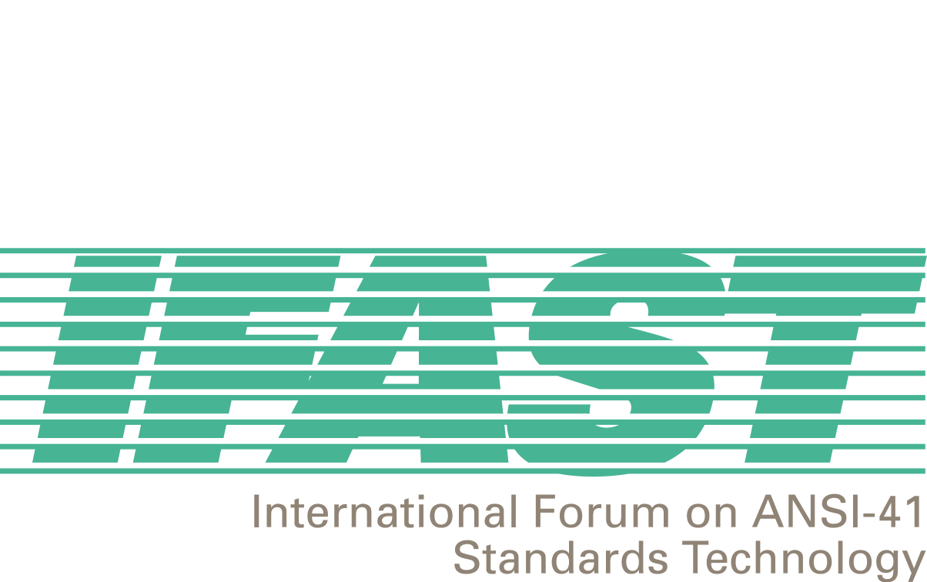

IFAST14: 4-5 October 2000

Current List of IFAST Study Projects

The following list contains all the currently approved IFAST Study Projects. Each listed Study Project contains a title and the name of its mentor. In some instances, an outline of the Project’s Work Plan is also provided.

Project 1: International TLDN – Ricardo Gomez

- Mentor Group to create a letter to the IFAST membership and TR45 documenting the issue, requirements, and potential solutions.
- Industry to provide comments in response to the letter.
- Review project and comments at IFAST15 to determine the ongoing project Work Plan.

Project 2: IMSI Implementation, Backward Compatibility, and MIN-based IMSI versus True IMSI– Ied Al Shaer

- Document E.212 implementation requirements for ANSI-41 networks.
- Identify potential national implementation issues.
- Address/resolve identified issues on an IFAST-wide basis.

Project 3: Uniform Dialing Plan, Support of Supplemental Services, and Future Feature Code Standardization – Fred Gaechter

- Identify dialing plan components potentially appropriate for worldwide uniformity in ANSI-41 networks.
- Determine current worldwide dialing plan components’ implementations.
- Develop a migration plan for worldwide uniformity implementation.

Project 4: WIN-based Services – Mike Doyle

- Pre-paid international roaming
- Wireless FreePhone service
- Location-based services

Project 5: International Roaming Guide (IRG) – Fred Gaechter

- Include current Projects plus other pertinent international roaming-related information.
- Include a section on “Fraud when Roaming Internationally”.

Project 6: Billing Related to International Roaming – VACANT

Project 7: SS7-Related Issues - Mike Doyle

- Routing Data
- ANSI to ITU SS7 Gateway Issues
- Short Message Service

Project 8: Optimal Routing – David Crowe

Project 9: Roaming Agreement Modeling – Aldofo Acevedo

Project 10: ANI Compatibility – Ricardo Gomez, Bernardo Martinez

