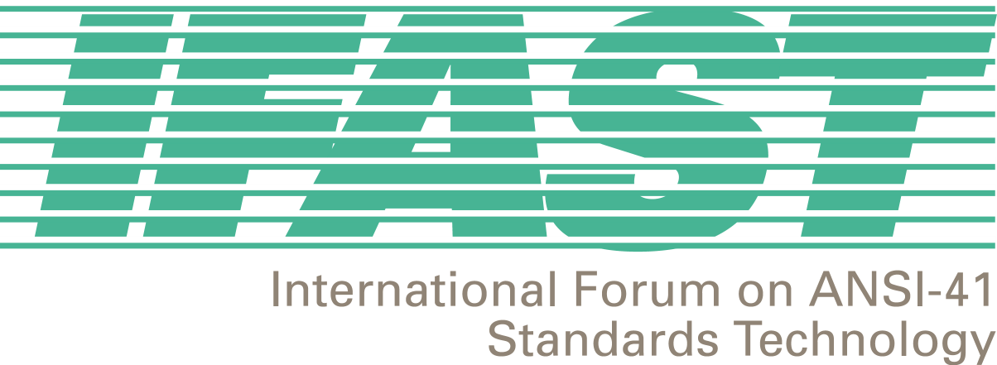
IFAST 15 Meeting
Carmel, CA, USA
January 24-25, 2001

Agenda
Chaired by Fred Gaechter

1. Introductory Session

- Call to Order and Opening Remarks - Fred Gaechter

- Attendance Roster and Introductions – Megan Hayes/Fred Gaechter

- Agenda Review and Approval – Fred Gaechter

- Introduction of Contributions and Numbering – Megan Hayes

2. Correspondence, Liaison and Update Session

- IFAST Website – Bernardo Martinez

- IRM/SID Update – David Crowe

- IRM Assignment Database – David Crowe (IRM Administrator)

- TR45.2 Update – David Crowe

- IRM Fee Updates – Megan Hayes

- Correspondence – Incoming and Outgoing (including letters from IFAST14 Action Items) – Ed Hall/Megan Hayes

Plenary Session

- Review action items from IFAST14 – Fred Gaechter

- Modifications to IRM Assignment Guidelines – Fred Gaechter

- Contribution to T1S1.3 regarding assignment of US SS7 Point Codes – Carlos Zamora/Fred Gaechter

- Cross Technology Roaming – Doug Rollender

- Introduction of Other New Issues for Discussion at this Meeting – Fred Gaechter

4. IFAST Study Project Updates

- International TLDN – Bernardo Martinez and Ricardo Gomez

- IMSI Implementation, Backward Compatibility, and MIN-based IMSI versus True IMSI– Ied Al Shaer

- Uniform Dialing Plan, Support of Supplemental Services, and Future Feature Code Standardization – Fred Gaechter

- WIN-based Services – Mike Doyle

- International Roaming Guide (IRG) – Fred Gaechter

- Billing Related to International Roaming – VACANT

- SS7 Routing Data – Mike Doyle

- Optimal Routing – David Crowe

- Roaming Agreement Modeling – Aldofo Acevedo

- ANI Compatibility – Ricardo Gomez and Bernardo Martinez

Closing Plenary

- Next Meeting Decision – Fred Gaechter

- Meeting Notes Review – Megan Hayes

- Action Items Review – Megan Hayes

- Closing Comments – Fred Gaechter

