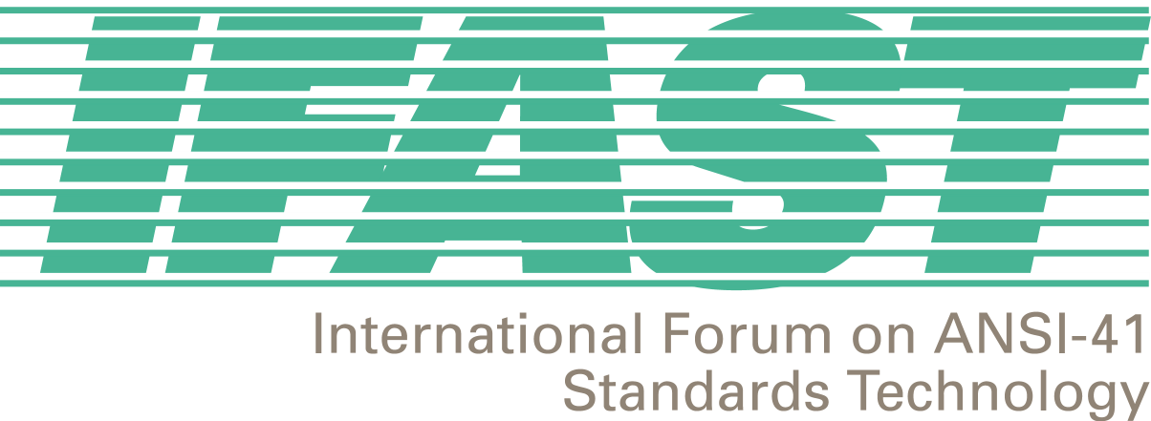
IFAST 15 Meeting
Carmel, CA, USA
January 24-25, 2001

Agreements and Action Items
Chaired by Fred Gaechter

Agreements Reached

- Once an IRM is categorized as OWING, there are six-months until a reclamation would occur. At five months, a letter would be sent, reminding them that they have 30 days for payment until a reclamation is made. Following the reclamation, the six-month dormant period applies, after which the IRM is re-assignable. This information will be reflected on the website.

- Agreed to the scope and purpose of the International Roaming Guide.

- Reviewed, agreed, and accepted the outcome of the completed action items from IFAST14.

- The Chair will call ANATEL to solicit their assistance in the resolution of the shared IRM issue in Brazil, between Americel and TCO. The Chair will also contact the Brazilian Wireless Industry Forum for similar assistance.

- Currently, IFAST has no role in the development of standards for Cross Technology Roaming, but should add a section to the International Roaming Guide.

- Reviewed, modified and approved IRMG V 2.0 for publication.

- Accepted contribution IFAST15/01.01.25.19 (GTT) to be added to the draft contribution for Committee T1S1.3 (IFAST15/01.01.24.6A) entitled: Assignment of ANSI SS7 Signaling Destination Point Code to Mobile Operators outside the United States. Draft Contribution will be distributed to IFAST for final review and comment.

- Reviewed and approved draft letter regarding Optimal Routing for submission to CDG/UWCC, (IFAST15/01.01.25.20).

- Agreed to change next IFAST meeting from Seattle to Ixtapa, MX. Dates moved to May 15-16, 2001. Agreed to IFAST 17 as Sept 11-12, 2001.

Action Items

- IUSACELL will provide the Secretariat the payment schedule for the website operation. (Ricardo Gomez)

- The IRM Assignment Guidelines will be updated to reflect the agreement of reclamation procedure with regard to non-payment. (Fred Gaechter)

- Provide electronic IFAST Contributions to the Secretariat two weeks in advance of meetings. (All IFAST Members)

- Contact Motorola to determine if there are any IMSI recommendations that can be presented at IFAST16. (David Crowe)

- Invite an expert on WIN-based pre-paid, Free Phone and location services to provide a presentation on these services at IFAST16 (David Crowe, Peter Oldfield.)

- Confirm Mentors for each Study Group and determine their continuing interest to perform the mentor function. (Ed Hall, Megan Hayes)

- Create a cover letter introducing IFAST to other appropriate industry committees (e.g., UWCC, CDG, and GSM-NA) and proposing a continuing liaison effort. (Fred Gaechter, Ed Hall)

- Add text to the SS7 contribution to T1S1.3 to explain the problems with Global Titles. (David Crowe and Zaeem Hosain)

- Coordinate presenters of and supporters for the contribution to the April T1S1.3 meeting. (Fred Gaechter)

- Combine Contributions IFAST15/01.16 and IFAST15/01.16A and send to all pertinent industry organizations (i.e., CITEL PCC-1, TR46, GSM-NA, CTIA, ATIS, T1, TR45, CDG, UWCC) to coordinate an awareness program that includes a proposed implementation plan schedule for the international TLDN standard. (Ricardo Gomez and Ed Hall)

- Contact Mike Doyle and Ken Hammer from TSI Connections to determine their interest in continuing their mentorship roles. (Fred Gaechter)

- Draft a letter describing the Optimal Routing issue to pertinent industry organizations to see if any of their members would be interested in getting involved in this project. (David Crowe)

- Put the Roaming Agreement Model on the website and solicit comments from the IFAST membership. (Adolfo Acevedo and Megan Hayes)

- Circulate a Uniformity Survey to all IFAST members for comment and carbon copy TR45.2, CDG, and UWCC. (Fred Gaechter)

- Create an editing team to enhance the current iteration of the International Roaming Guide (IRG) for publication and distribution at IFAST16. (Fred Gaechter, David Crowe, Megan Hayes)

- Determine if ANI Compatibility is a continuing issue and report to IFAST16. (Ricardo Gomez)

- Develop text on Cross Technology Roaming for the IRG. (Doug Rollender)

- Add a section to the website for each of the Study Projects. (Ricardo Gomez)

- Circulate T1S1.3 contribution RE: GTT to IFAST for final review and comment. (Fred Gaechter, Megan Hayes)

- Prepare and deliver final letter to CDG and UWCC regarding Optimal Routing. (David Crowe and Megan Hayes)

- The Chair will call ANATEL to solicit their assistance in the resolution of the shared IRM issue in Brazil, between Americel and TCO. The Chair will also contact the Brazilian Wireless Industry Forum for similar assistance. Follow-up in writing. (Fred Gaechter)

